KIS Pool Checker – Horizon Pool Monitor
Prepared by Keep IT simple - 2021-12-21
Written by Charles Silverman

Contents
Installation 2
Install VMware Power CLI 2
Install Horizon advanced functions 2
Install and configure the script 3
Test the script 3
Configure Scheduled Task 4
Troubleshooting 7

Installation

Install VMware Power CLI
- Open an administrator PowerShell window
- Type the following command to install PowerCLI:
Install-Module VMware.PowerCLI -Scope AllUsers
NOTE: If the installation fails, you may need to enable TLS 1.2 with the following command:
[Net.ServicePointManager]::SecurityProtocol = [Net.SecurityProtocolType]::Tls12
- Allow execution of local scripts by typing the following command:
Set-ExecutionPolicy RemoteSigned

Install Horizon advanced functions
- Go to the GitHub repository page at https://github.com/vmware/PowerCLI-Example-Scripts.
- Click the green Clone or download button and then click Download ZIP.
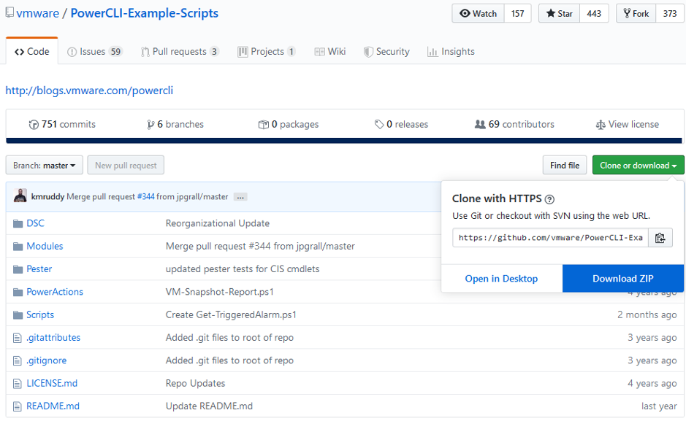
- Extract the ZIP file and copy the Modules\VMware.HV.Helper folder to one of the following modules directories (create the path if it is missing):
- User specific: %UserProfile%\Documents\WindowsPowerShell\Modules
- System wide: C:\Program Files\WindowsPowerShell\Modules
- Unblock the advanced functions to allow them to be executed. In a PowerShell prompt (as Administrator), run the following command, tailoring the path to where you copied the VMware.Hv.Helper folder:
dir ‘C:\Program Files\WindowsPowerShell\Modules\VMware.Hv.Helper\’ | Unblock-File
- (Optional) If you cannot use a server name that matches the SSL certificate for your Horizon server, run the following command to ignore certificate errors:
Set-PowerCLIConfiguration -InvalidCertificateAction Ignore -Confirm:$false

- (Optional) Configure PowerCLI Customer Experience Improvement Program (CIEP) by launching an administrator powershell and running the following command:
This command will prevent the warning message about the CEIP when you run this script. You can change the setting to $true if you wish to participate in the CEIP.
Set-PowerCLIConfiguration -Scope User -ParticipateInCEIP $false

Install and configure the script
- Copy the KISPoolChecker.ps1 file into a folder. Ex: C:\Scripts
- Create a file named KISPoolChecker.cfg in the same folder as the script that looks like the following, substituting the appropriate information where applicable:
OrganizationName=My Organization
HorizonServer=horizonserver.mydomain.com
SMTPServer=mailserver.mydomain.com
SMTPFrom=poolcheck@mydomain.com
SMTPTo=recipient@mydomain.com
SMTPPort=25
SMTPSSL=False
If you want to send to multiple recipients, separate them by a comma.
The last two lines are optional if you need to specify a different port for your SMTP server and if the server requires an SSL connection.
- Ensure that the user you want to run the script as has full rights to the specified folder. This may require that the user have specific rights to the folder.

Test the script
- Log into the Horizon Console and Disable one of the desktop pools.
- From a PowerShell window, navigate to the folder containing the KISPoolChecker.ps1 file.
- Run the KISPoolChecker.ps1 script with the -credential parameter to store the Horizon credentials for the current user. These credentials are being stored only for the currently logged in user. If you wish to automate this script for another user, log into Windows as that user.
.\KISPoolChecker.ps1 -credential
NOTE: You can run this command again if you need to update the credentials for the current user.
- You will be prompted for credentials for the Horizon Console. The user name MUST be in the domain\userid format. Please note that these credentials are being stored only for the currently logged in user. If you wish to automate this script for another user, log into Windows as that user.
- (Optional) If you require authentication for your SMTP server, run the following command:
.\KISPoolChecker.ps1 -smtpcredential
Enter your user ID and password required for authenticating to the SMTP server. As with the Horizon credentials, these credentials are being stored only for the currently logged in user. If you wish to automate this script for another user, log into Windows as that user.
- Run the KISPoolChecker.ps1 script again with the -test parameter to verify that everything works properly without sending e-mail:
.\KISPoolChecker.ps1 -test
- Your output will look like the following if pools are found with provisioning disabled:
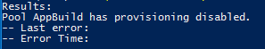
- Run the KISPoolChecker.ps1 script one more time with no parameters to test e-mail functionality:
.\KISPoolChecker.ps1
- If everything worked properly, you should have received an e-mail alert.

Configure Scheduled Task
- Open the task scheduler. You can do this by clicking start and typing taskschd.msc and pressing Enter.
- Ensure that Task Scheduler (Local) is selected in the left panel and click Create Task… in the right panel.
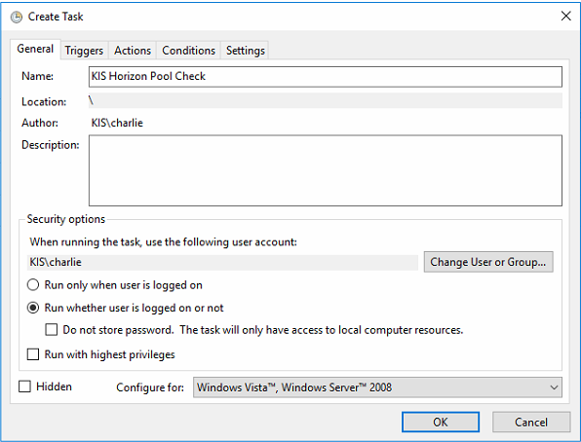
- Enter a name for the task.
- Ensure that the Run whether user is logged in or not option is selected. This task must be run as a specific user account and cannot be run as system.
- Click the Triggers tab and click the New… button.
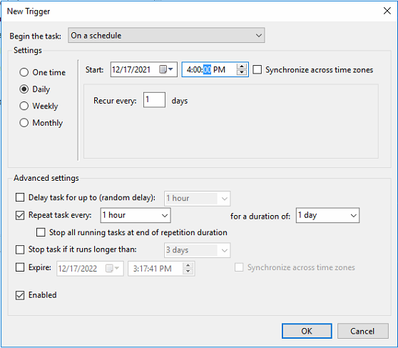
- Check the Daily option on the left.
- Set the start time for today's date and the next hour.
- Ensure that the task is set to recur every 1 days.
- Check the Repeat task every box and set it to 1 hour for a duration of 1 day.
- Ensure that the Enabled box is checked.
- Click OK.
- Click the Actions tab and click the New… button.
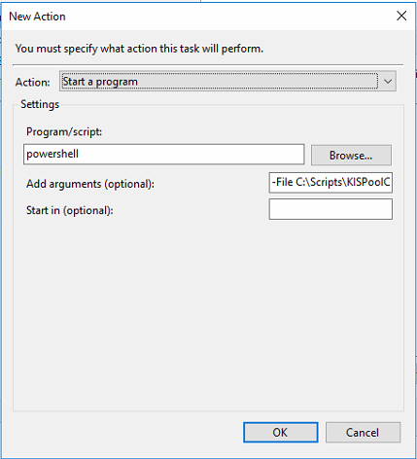
- Ensure that the action is set to Start a program.
- In the Program/script box, enter powershell
- In the Add arguments box, enter the following, with the appropriate path where you placed the script file:
-File C:\Scripts\KISPoolChecker.ps1
- Click OK.
- Click on the Settings tab.
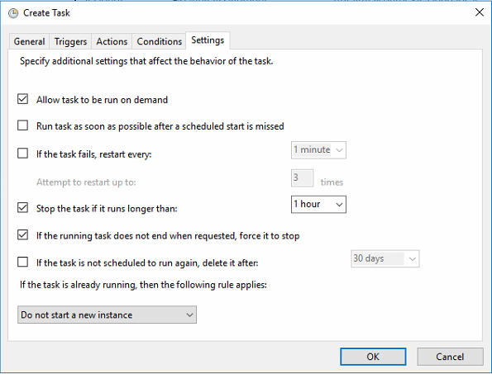
- Ensure that the Stop the task if it runs longer than box is checked and set it to 1 hour.
- Click OK to create the task.
- You will be prompted to enter the Windows credentials for the current user to save into the task. Enter the password for your current user account and click OK.

Troubleshooting
The script will output to a log file named KISPoolChecker.log in the same folder as the script. This log may help troubleshoot issues.
If you receive an error that the script is unable to read the KISPoolChecker.cfg file, please ensure that the user has been granted full rights to the folder containing the script file and config file.

